COMMUNITY COLLEGE OF PHILADELPHIA

New Degree Program Proposal

Name of Degree Program | Biomedical Equipment Technology
Academic Pathway | Science and Technology
Department | Physics
Faculty Developer(s) | Randy Libros
Facilitator | Amy Birge-Caracappa
Recommended Starting Semester | Fall 2021
Today’s Date | February 22, 2021
Abstract | The Biomedical Equipment Technology (BMET) program currently exists as a stackable certificate program that leads to an AAS degree in Applied Science and Engineering Technology (ASET). The ASET program is undergoing a revision intended, in part, to create a student pathway that will be clearer to students. At the same time, the BMET certificate program has a clear pathway to completion, and has graduated 54 students in the past 4 years, with around 85% of them finding sustainable employment in the field. The contents and structure of the curriculum will not change. The program will continue to be guided by the Core Curriculum project developed by the Association for the Advancement of Medical Instrumentation (AAMI), the international professional organization.  Establishing the BMET program as a stand-alone AAS degree program, while retaining the stackable credentials model, will provide an associate degree that is clearer to students and clearer to employers. In addition, enabling students to earn an AAS in Biomedical Equipment Technology will make them eligible to become a Certified Biomedical Equipment Technician more quickly.

- Alignment with the College Mission

The Biomedical Equipment Technology Program already exists as a stackable credentials program, consisting of two proficiency certificates that build towards an Associates of Applied Sciences in Applied Science and Engineering Technology. In its current form, the program is aligned with the College Mission in that it provides a coherent foundation for employment and lifelong learning. The traditional entry level degree in this field has been the associates degree, however we have found that around 75% of students who successfully complete only the BMET I Proficiency Certificate—which can be completed in a year—have been able to find sustainable employment as Biomedical Equipment Technicians in the field of Healthcare Technology Management (HTM). For students who complete the BMET II Proficiency Certificate and/or the associate’s degree in Applied Science and Engineering Technology, the percentage of students who have found employment in the field rises to around 85%. Note that these numbers may be low due to the challenges inherent in tracking all student employment outcomes.

The field of HTM faces ongoing change, as new technologies are introduced in the field of medicine. Inherent in the profession is the need for lifelong learning on the part of Biomedical Equipment Technicians (BMETs), and the program is designed to provide a strong foundation in the operating principles of medical devices, electronics, and networking, so that students who later work in the field are prepared to learn and apply new knowledge.

HTM is currently facing a major challenge, both regionally and nationally, due to the large number of retirements that are occurring in the field, which are expected to continue in upcoming years. The BMET program fulfills an important role in the economic life of the city and the region by providing graduates who are ready to enter the field ready to work in support of our healthcare system.

Students in the program represent a broad range of backgrounds who benefit from the program by attaining knowledge and skills which give them entre to sustainable employment in the HTM field.

- Expected Program Participants

The BMET Program will prepare students to repair and maintain medical equipment utilized in hospitals and other healthcare environments. The program will be of particular interest to students who want to work in the healthcare arena but are more interested in working with medical technology and supporting the healthcare providers who utilize the equipment than in providing direct patient care. The program is intended to provide students with direct entry to the work environment, and students are expected to find employment in hospitals, with third-party organizations that hospitals may contract with for healthcare technology management services, and with medical device manufacturers who need to provide technical support to their customers. Additional employment opportunities may be found at dialysis centers, medical equipment rental companies, etc.

Since the program has been running as a stackable certificate program leading to an AAS degree in Applied Science and Engineering Technology, we already have a good idea of where students come from who enter the program and why. Some students who enter the program may initially come to the College for Nursing or Allied Health careers, but for various reasons they may decide that BMET is a better fit for them. Employees of area hospitals who interface with their own Biomedical Engineering departments may also seek out further education to move into the field. High school students looking for a hands-on technical career would also find the program interesting. In addition, students may independently learn about the program and search out a place where they can gain the necessary credentials to enter the field. Since this is the only such program in the region, we also have seen a small number of students who come to the College specifically for the program from other Pennsylvania counties and even from New Jersey.

Enrollment in the program will be limited to 24 in each cohort. There are several reasons for this:
- We do not want to exceed the expected job market capacity with too large a number of students.
- The program includes two internship experiences, and we do not want to exceed the capacity of the region to support the number of students we have.
- Lab space cannot accommodate more than 24 students.

Students will need to be college-ready in both Math and English in order to take courses in the program. Once in the program, student progress is monitored, and students are provided guidance in being successful in their courses, as well as ensuring that they are appropriately registered for courses. This is carried out by the Program Coordinator, who also carries out student recruitment efforts to ensure full enrollment in the program.

- Opportunities and/or Problems that the Proposed Program Addresses

The program provides students with a direct pathway to sustainable employment as Biomedical Equipment Technicians. While national employment growth in the field is projected to be about average (https://www.bls.gov/ooh/installation-maintenance-and-repair/medical-equipment-repairers.htm), the need for replacement of employees due to retirement is significant. According to TechNation, an industry journal, “It is estimated that a fifth to a quarter of the entire HTM field will retire in the next 10 years and many already have.” (9/1/2017). 24x7, another industry journal, referring to their annual industry salary survey, stated, “More than one-third—36% to be exact—of 2019 respondents were in the 55-and-older age bracket.” (January 2020). The presence of this need regionally has been consistently reinforced by our Advisory Board. Advisory Board members have consistently related their frustrations with trying to find qualified job applicants for openings in their departments, and they are invested in the success of the BMET program at the College because it addresses a critical need in the industry. There are currently no other Associate Degree BMET programs in the region.

Data from EMSI clearly indicates a large number of positions posted both in the City and in the region. Further information about employment demand in the region can be found in the appendix.

- Program Structure and Coherence

The safe and effective use of medical technology is the central focus of Healthcare Technology Management (HTM), and BMETs are an important component of this field. The web site of the Association for the Advancement of Medical Instrumentation puts it this way:

As a healthcare technology management (HTM) professional, you are a key member of the healthcare delivery care team by managing, repairing, and utilizing health technology. Working with clinicians and patients, HTM professionals ensure the highest standards and best practices in medical device safety, security, interoperability, and functionality. (www.aami.org/htm)

In particular, BMETs are responsible for regularly inspecting medical devices used in hospitals and other healthcare settings to ensure they are working safely, properly, and within industry defined specifications. BMETs need to understand the operation of medical devices, so they can troubleshoot and repair medical equipment that is not functioning properly, and increasingly they must have a clear understanding of computer networks, as hospitals have become highly networked environments. To be effective in their jobs, BMETs must be able to communicate equally well with clinicians (such as nurses, respiratory therapists, clinical lab technicians, and doctors) and with network specialists. This requires basic knowledge, understanding and vocabulary of these fields, as well as effective customer service skills. Much of these topics are addressed in the existing BMET courses; however, some basic knowledge is best addressed by other courses, some in other departments.

For example, a basic understanding of human anatomy and physiology (e.g., BIOL 108) helps BMETs understand what clinicians are trying to accomplish when they use medical devices such as heart monitors and blood pressure monitors to measure physiological parameters, or when they use a medical device such as a defibrillator or ventilator to provide treatment to a patient.

Basic principles of physics and chemistry are important for understanding the operation of many medical devices. For example, pulse oximeters, that measure the oxygen saturation of the blood, rely on an understanding of light absorption and the effect of concentration and light wavelength. Chemistry and physics courses provide a foundation in these, and other areas that help students understand the specific applications in medical devices.

The program will retain the stackable credentials model that has been very successful while the program was under the umbrella of the ASET program.

Rationale for the Number of Credits: The BMET program requires a minimum of 70 credits for graduation. The need for 70 credits is based on our efforts to come as close as possible to the recommendations of the Association for the Advancement of Medical Instrumentation (AAMI) in their document, “Core Competencies for the HTM Entry-level Technician A Guide for Curriculum Development in Academic Institutions Second Edition, 2016”, which can be made available upon request. The document lists core competencies in 10 content areas, divided into
Functional Core Competencies and Personal Core Competencies, as follows:

- Biomedical Equipment Technology
- Electronics
- Information Technology
- Anatomy and Physiology
- Mathematics
- Physics
- Chemistry
- Communication Skills
- Professional
- Clinical Competency—Internship/Laboratory

The proposed course sequence attempts to fulfill as much of these core competencies as possible.

The curriculum has also been vetted and reviewed by the BMET Advisory Board. Ongoing assessment of the efficacy of the program is carried out during internship site visits. At that time, internship site supervisors, who are typically supervisors or managers in the Healthcare Technology department where students are placed, are asked if students seemed well prepared for the internship and if they had any suggestions for areas subject areas where there seemed to be gaps in students’ knowledge. There were some early suggestions of small adjustments (such as giving students more exposure to use of hand tools, which we were able to easily accomplish through adjustments to the labs) but no real gaps in overall knowledge. Further, when asked if they would consider hiring the intern(s) they had supervised to an entry level position, the answer has been an overwhelming yes, with only a very few exceptions over the past five years. This is, of course a testament not only to the efficacy of the program, but also to the dedication and competency of our students.

- Assessment Plan

Student Learning Outcome | Frequency of Assessment | How Assessed*
 |  | Direct Assessment | Indirect Assessment
Apply knowledge of medical devices, electronics, computer networks and anatomy and physiology to resolving medical equipment repair problems. | Alternate years | BMET 201: CLOs 1,3,4,6  BMET 102: CLO 10 | Percent of BMET students achieving a grade of C or better in CIS 150 and ELEC 130
 |  | BMET 103: CLO 1
 |  | BMET 202: CLOs 3,4,7
 |  | BMET 203: CLO 2,3
Demonstrate professional behavior in the workplace such as teamwork, communication, etc. | Alternate years | BMET 103: CLO 4
 |  | BMET 203: CLO 6
Work in accordance with applicable safety procedures to ensure their own safety, as well as that of patients and other employees. | Alternate years | BMET 103: CLO 2
 |  | BMET 201: CLO 2
 |  | BMET 203: CLO 4
Follow applicable department, hospital and legal guidelines in relation to record keeping, patient privacy, etc. | Alternate years | BMET 103: CLO 2
 |  | BMET 201: CLO 5
 |  | BMET 202: CLO 1
 |  | BMET 203: CLO 4,5

In addition to the assessments listed above, the following indirect assessment methods will also be utilized: tracking of student persistence; tracking of graduation rates; percentage of students who find employment in the field.

Curriculum Map:

Required Courses | Program Learning outcomes
 | Apply knowledge of medical devices, electronics, computer networks and anatomy and physiology to resolving medical equipment repair problems. | Demonstrate professional behavior in the workplace such as teamwork, communication, etc. | Work in accordance with applicable safety procedures to ensure their own safety, as well as that of patients and other employees. | Follow applicable department, hospital and legal guidelines in relation to record keeping, patient privacy, etc.
BMET 101 | I | I | I | I
BIOL 108 | I, R
BMET 102 | I, R, A | I, R | I, R | I, R
BMET 103 | R, A | R, A | R, A | R, A
BMET 201 | R, A | R | R, A | R, A
ELEC 130 | I, R
CIS 150 | I, R
BMET 202 | R, A | R | R | R, A
BMET 203 | R, A | R, A | R, A | R, A

Key: I—Introduced, R—Reinforced and opportunity to practice, A—Assessment evidence collected

- Effect on Other Programs and Courses

The BMET proficiency certificate program has been embedded in the Applied Science and Engineering Technology (ASET) program for the past six years. The ASET program is undergoing a revision and will be renamed Applied Engineering Technology. In order to provide clearer pathways to students, it was decided to separate the BMET program into its own associate’s degree program. An additional advantage for students is that they can be eligible to become a Certified Biomedical Equipment Technician more quickly. The BMET AAS will also further clarify what jobs students are qualified for to professionals in industry.

- Proposed New Courses and Course Revisions

No new courses are proposed as all of the program courses already exist.

- Fiscal Implications

As the BMET I and II PCs have already been functioning since Fall 2015, there are no associated startup costs. There is an ongoing need for an operating budget to cover the cost of supplies and for a program coordinator.

Labs for the program are carried out in W4-37. This lab was designed with the BMET program in mind.

- Catalog Page

Biomedical Equipment Technology
Program Description: The Biomedical Equipment Technology Program prepares students to repair and maintain medical equipment utilized in hospitals and other healthcare environments. The program will be of particular interest to students who want to work in the healthcare arena but are more interested in working with medical technology and supporting the healthcare providers who utilize the equipment than in providing direct patient care. The program is intended to provide students with direct entry to the work environment, and students are expected to find employment in hospitals, with third-party organizations that hospitals may contract with for healthcare technology management services, and with medical device manufacturers who need to provide technical support to their customers. Additional employment opportunities may be found at dialysis centers, medical equipment rental companies, etc.

Program Learning Outcomes:

Upon successful completion of this program, students will be able to:

- Apply knowledge of medical devices, electronics, computer networks and anatomy and physiology to resolving medical equipment repair problems.
- Demonstrate professional behavior in the workplace such as teamwork, communication, etc.
- Work in accordance with applicable safety procedures to ensure their own safety, as well as that of patients and other employees.
- Follow applicable department, hospital and legal guidelines in relation to record keeping, patient privacy, etc.

Program Entry Requirements: This program is open to interested students. However, new students are normally required to take the College's placement test at their time of entry. Students' placement test results must show readiness for ENGL 101 and FNMT 118 or higher for admission to the program. Internship is required for completion of the program and adds significantly to student learning and preparation to enter the workforce. The hospitals where students perform their internships require various clearances, such as medical clearances, criminal and child abuse background checks and drug screening.

Program of Study and Graduation Requirements: To qualify for the A.A.S. degree in Biomedical Equipment Technology, students must complete a minimum of 70 credit hours as prescribed and attain a grade point average of 2.0 ("C" average). A grade of “C” or better is required for all courses applied towards the degree. Students who follow the course sequence below may complete the degree in two years.

Course Sequence:

Semester 1
Course Number and Name | Prerequisites and Corequisites | Credits | Gen Ed Req.
FNMT 118 - Intermediate Algebra or a higher level math course | FNMT 017 or FNMT 019 completed or FNMT 118 (or higher) placement | 3 credits | Quantitative Reasoning
BIOL 108 - Essentials of Human Anatomy and Physiology or  BIOL 110 - Anatomy and Physiology II* | For BIOL 108: FNMT 118 (or higher) placement  For BIOL 110: BIOL 109 | 4 credits | Scientific Reasoning
BMET 101 - Biomedical Equipment Technology I | BIOL 108 or BIOL 110, which may be taken concurrently | 4 credits
CIS 103 - Computer Applications & Concepts |  | 3 credits | Technological Competency
ENGL 101 - English Composition I |  | 3 credits | Writing/Research/Info Lit 1

Semester 2
Course Number and Name | Prerequisites and Corequisites | Credits | Gen Ed Req.
ENGL 102 - The Research Paper | ENGL 101 with a grade of "C" or better | 3 credits | Writing/Research/Info Lit 2
ELEC 120 - Direct and Alternating Current Circuits | FNMT 118 or higher MATH with a grade of "C" or better or placement in MATH 161 or higher | 4 credits
BMET 102 - Biomedical Equipment Technology II | BMET 101 with a grade of "C" or better and ELEC 120, which may be taken concurrently | 4 credits
CIS 105 - Computer Systems Maintenance |  | 4 credits
ENGL 115 - Public Speaking or  ENGL 116 - Interpersonal Communication or  ENGL 117 - Group and Team Communication or  ENGL 118 - Intercultural Communication | ENGL 101, which may be taken concurrently | 3 credits | Oral Communication/  Creative Expression

Summer
Course Number and Name | Prerequisites and Corequisites | Credits | Gen Ed Req.
BMET 103 - Biomedical Equipment Technology Internship I | BMET 102 with a "C" or better and FNMT 118 or higher. Department Head approval is required to ensure that students have completed the necessary clearances. | 1 credit

Semester 3
Course Number and Name | Prerequisites and Corequisites | Credits | Gen Ed Req.
ELEC 124 - Semiconductor Devices | ELEC 120 with a grade of "C" or better | 4 credits
CHEM 110 - Introductory Chemistry  or higher level chemistry | FNMT 118 ready and ENGL 101 ready | 4 credits
BMET 201 - Medical Devices | BMET 103 with a grade "C" or better | 4 credits
CIS 150 - Network Technology |  | 4 credits

Semester 4
Course Number and Name | Prerequisites and Corequisites | Credits | Gen Ed Req.
PHYS 105 - Survey of Physics or higher physics course (except PHYS 108 -Astronomy) |  | 4 credits
BMET 202 - Medical Devices in a Networked Environment | BMET 201; ELEC 130, which may be taken concurrently; CIS 105; and CIS 150 with a grade of "C" or better in all courses | 4 credits
ANTH 112 - Cultural Anthropology or  HIST 150 - History of American Health Care or PSYC 101: Introduction to Psychology or  SOC 101 - Introduction to Sociology or  SOC 105: Health and Society, or  SOC 115 - Gender and Society |  | 3 credits | Cultural Analysis & Interpretation
ELEC 130 - Digital Electronics | FNMT 118 completed or higher math placement | 4 credits

Summer
Course Number and Name | Prerequisites and Corequisites | Credits | Gen Ed Req.
BMET 203 - Biomedical Equipment Technology Internship II | BMET 202 (with a "C" or better) Department Head approval is required to ensure that students have completed the necessary clearances. | 3 credits

Minimum Credits Needed to Graduate: 70

* Students who choose to take BIOL 109-110: Anatomy and Physiology I & II will earn an additional four credits.

General Education Requirements: All general education requirements necessary for graduation are met through the courses in the program as indicated above. Students who wish to take courses that differ from the general education courses indicated above must complete a course substitution request form. To access the form, login to the MyCCP portal, and in the Student tab, under Electronic Forms, click on the Records and Registration Forms link, then choose Request for Course Substitution of Graduation Requirement link. A more detailed explanation of the College’s general education requirements is also available.

For More Information, Contact: The Division of Math, Science, and Health Careers, Room W1-1, 1700 Spring Garden Street, Philadelphia, PA 19130, Telephone (215) 751-8430 or the College Information Center (215) 751-8010.

- Courses and Completion Sequence

The following courses and sequence of courses is designed for the optimal success and completion of the Biomedical Equipment Technology degree/certificate. Any alterations should be discussed with your academic advisor.

Semester 1
Course Number and Name | Credits | Advisory Notes | Course Type
FNMT 118 - Intermediate Algebra or a higher level math course | 3 credits | Prerequisite for ELEC 120 | Quantitative Reasoning
BIOL 108 - Essentials of Human Anatomy and Physiology or  BIOL 110 - Anatomy and Physiology II * | 4 credits | Prerequisite for BMET 101, which may be taken concurrently | Scientific Reasoning
BMET 101 - Biomedical Equipment Technology I | 4 credits | Prerequisite for BMET 102 | Major Course
CIS 103 - Computer Applications & Concepts | 3 credits |  | Technological Competency
ENGL 101 - English Composition I | 3 credits | Prerequisite for ENGL 102; Must earn a C or better | Writing/Research/Info Lit 1

Semester 2
Course Number and Name | Credits | Advisory Notes | Course Type
ENGL 102 - The Research Paper | 3 credits |  | Writing/Research/Info Lit 2
ELEC 120 - Direct and Alternating Current Circuits | 4 credits | Prerequisite for ELEC 124 | Major Course
BMET 102 - Biomedical Equipment Technology II | 4 credits | Prerequisite for BMET 103 | Major Course
CIS 105 - Computer Systems Maintenance | 4 credits | Prerequisite for BMET 202, must earn a C or better | Major Course
ENGL 115 - Public Speaking or  ENGL 116 - Interpersonal Communication or  ENGL 117 - Group and Team Communication or  ENGL 118 - Intercultural Communication | 3 credits |  | Oral Communication/  Creative Expression

Summer
Course Number and Name | Credits | Advisory Notes | Course Type
BMET 103 - Biomedical Equipment Technology Internship I | 1 credit | Prerequisite for BMET 201. BMET 103 requires Department Head approval to ensure that students have completed the necessary clearances. | Major Course

Semester 3
Course Number and Name | Credits | Advisory Notes | Gen Ed Req.
ELEC 124 - Semiconductor Devices | 4 credits |  | Major Course
CHEM 110 - Introductory Chemistry  or higher level chemistry | 4 credits
BMET 201 - Medical Devices | 4 credits | Prerequisite for BMET 202 | Major Course
CIS 150 - Network Technology | 4 credits | Prerequisite for BMET 202; must earn a C or better

Semester 4
Course Number and Name | Credits | Advisory Notes | Course Type
PHYS 105 - Survey of Physics or higher physics course (except PHYS 108 -Astronomy) | 4 credits
BMET 202 - Medical Devices in a Networked Environment | 4 credits | Prerequisite for BMET 203 | Major Course
ANTH 112 - Cultural Anthropology or  HIST 150 - History of American Health Care or PSYC 101: Introduction to Psychology or  SOC 101 - Introduction to Sociology or  SOC 105: Health and Society, or  SOC 115 - Gender and Society | 3 credits |  | Cultural Analysis & Interpretation
ELEC 130 - Digital Electronics | 4 credits | Prerequisite for BMET 202, may be taken concurrently | Major Course

Summer
Course Number and Name | Credits | Advisory Notes | Course T ype
BMET 203 - Biomedical Equipment Technology Internship II | 3 credits | Department Head approval is required to ensure that students have completed the necessary clearances. | Major Course

- Appendix / Data

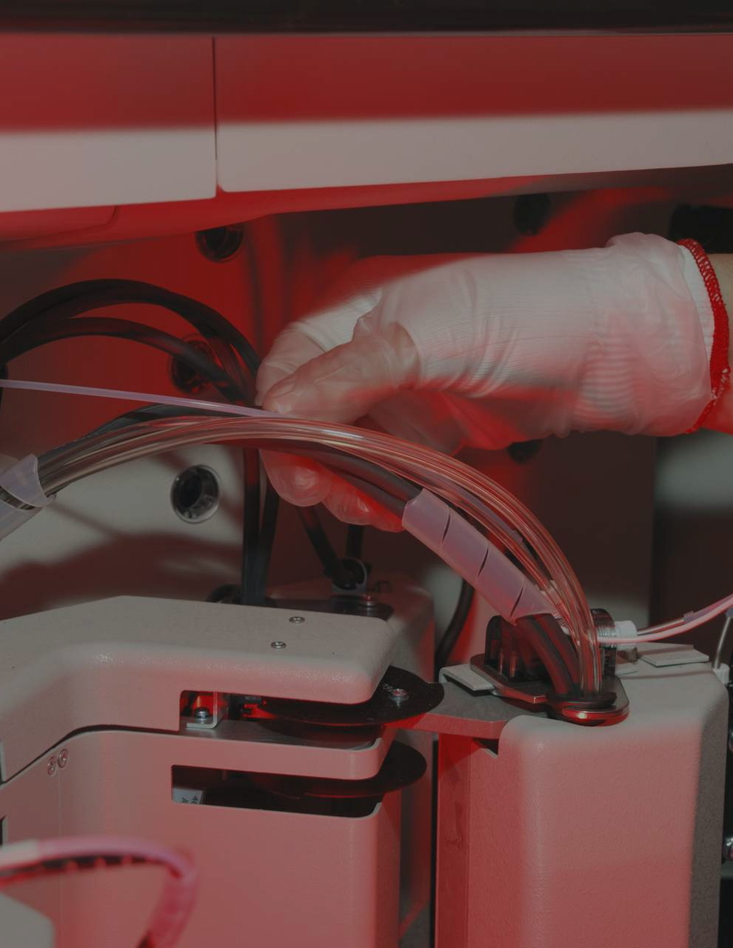
Occupation Overview

Medical Equipment Repairers
in 4 Pennsylvania Counties

Medical Equipment Repairers (SOC 49-9062):
Test, adjust, or repair biomedical or electromedical equipment.

Sample of Reported Job Titles: Biomedical Equipment Technician (BMET) Service Technician
Repair Technician
Certified Biomedical Equipment Technician (CBET) Biomedical Equipment Support Specialist Biomedical Equipment Specialist
Biomedical Engineering Technician (BMET) Biomedical Electronics Technician
Biomed Tech (Biomedical Technician) X-ray Service Technician

Related O*NET Occupation:
Medical Equipment Repairers (49-9062.00)

Contents

What is Emsi Data? 1
. .
. . . . . . . . . . . . . . . . .
Report Parameters 2
. .
. . . . . . . . . . . . . . . .
Executive Summary 3
. .
. . . . . . . . . . . . . . . . .
Jobs 4
. .
. . . .
Compensation 7
. .
. . . . . . . . . . . . .
Job Posting Activity 8
. .
. . . . . . . . . . . . . . . . .
Demographics 10
. . .
. . . . . . . . . . . . .
Occupational Programs 14
. . .
. . . . . . . . . . . . . . . . . . . .

What is Emsi Data?

Emsi data is a hybrid dataset derived from official government sources such as the US Census Bureau, Bureau of Economic Analysis, and Bureau of Labor Statistics. Leveraging the unique strengths of each source, our data modeling team creates an authoritative dataset that captures more than 99% of all workers in the United States. This core offering is then enriched with data from online social profiles, resumés, and job postings to give you a complete view of the workforce.
Emsi data is frequently cited in major publications such as The Atlantic, Forbes, Harvard Business Review, The New York Times, The Wall Street Journal, and USA Today.

Report Parameters

1 Occupation

49-9062 Medical Equipment Repairers

4 Counties

42017 | Bucks County, PA |  | 42091 Montgomery County, PA
42045 | Delaware County, PA |  | 42101 Philadelphia County, PA

Class of Worker
QCEW Employees

The information in this report pertains to the chosen occupation and geographical areas.

Executive Summary

Aggressive Job Posting Demand Over an Average Supply of Regional Jobs
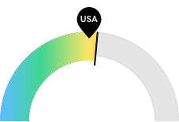
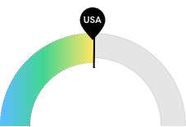
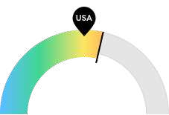

524

$49,388
20

Jobs (2014)

Compensation

Job Posting Demand

Your area is about average for this kind of job. The national average for an area this size is 482* employees, while there are 524 here.
Earnings are about average in your area. The national median salary for Medical Equipment Repairers is
$49,213, compared to
$49,388 here.
Job posting activity is high in your area. The national average for an area this size is 16* job postings/mo, while there are 20 here.

*National average values are derived by taking the national value for Medical Equipment Repairers and scaling it down to account for the difference in overall workforce size between the nation and your area. In other words, the values represent the national average adjusted for region size.

Jobs

Regional Employment Is About Equal to the National Average

An average area of this size typically has 482* jobs, while there are 524 here.
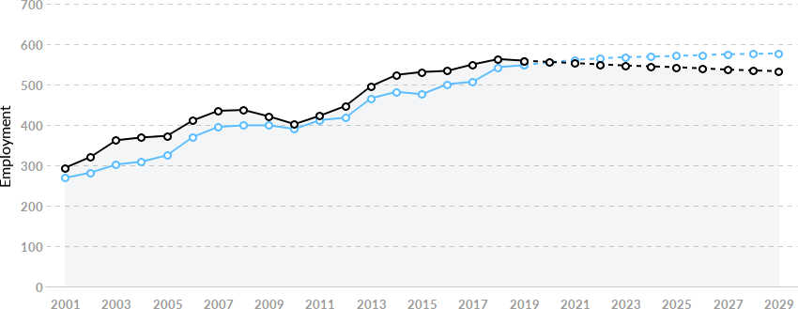

Region | 2014 Jobs | 2020 Jobs | Change | % Change
- 4 Pennsylvania Counties | 524 | 556 | 32 | 6.1%
- National Average | 482 | 555 | 74 | 15.3%

*National average values are derived by taking the national value for Medical Equipment Repairers and scaling it down to account for the difference in overall workforce size between the nation and your area. In other words, the values represent the national average adjusted for region size.

Regional Breakdown

County | 2014 Jobs
Montgomery County, PA | 190
Philadelphia County, PA | 175
Bucks County, PA | 88
Delaware County, PA | 70

Most Jobs are Found in the Professional and Commercial Equipment and Supplies Merchant Wholesalers Industry Sector

Industry
% of Occupation in Industry (2014)

⬤ Professional and Commercial Equipment and 29.8% Supplies Merchant Wholesalers

⬤ General Medical and Surgical Hospitals 17.8%

⬤
 | Electronic and Precision Equipment Repair and Maintenance
⬤ | Health and Personal Care Stores | 6.3%
⬤ | Outpatient Care Centers | 4.1%
⬤ | Management of Companies and Enterprises | 3.3%
⬤ | Other | 22.4%

16.2%

Compensation

Regional Compensation Is the Same Cost as the Nation

For Medical Equipment Repairers, the 2018 median wage in your area is $49,388, while the national median wage is $49,213.
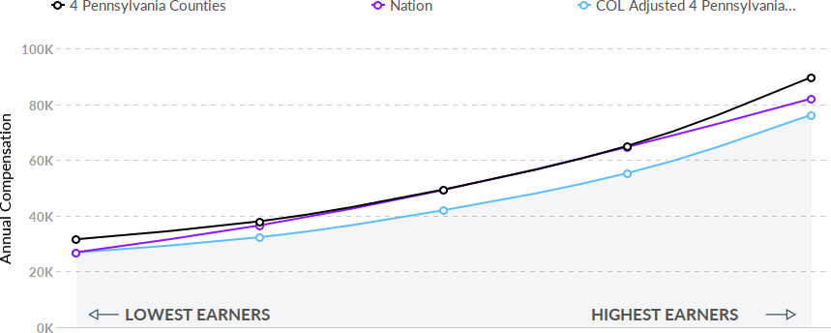

Job Posting Activity

845 Unique Job Postings

The number of unique postings for this job from Sep 2016 to Mar 2020.

216 Employers Competing

All employers in the region who posted for this job from Sep 2016 to Mar 2020.

44 Day Median Duration

Posting duration is 12 days longer than what's typical in the region.

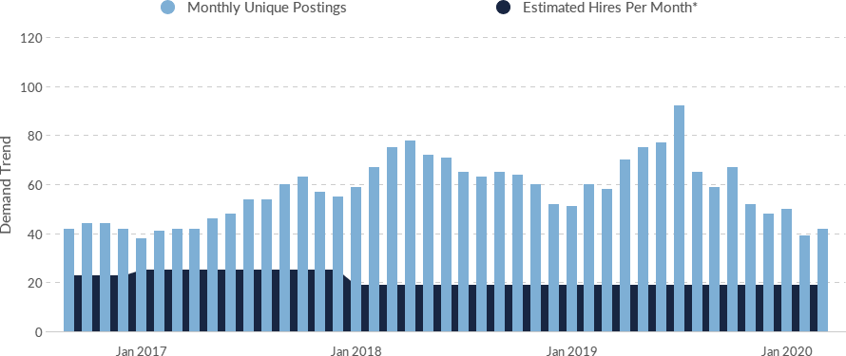

Occupation
Avg Monthly Postings (Sep 2016 -
Mar 2020)
Avg Monthly Hires (Sep 2016 - Mar
2020)

Medical Equipment Repairers

57 21

*A hire is reported by the Quarterly Workforce Indicators when an individual's Social Security Number appears on a company's payroll and was not there the quarter before. Emsi hires are calculated using a combination of Emsi jobs data, information on separation rates from the Bureau of Labor Statistics (BLS), and industry-based hires data from the Census Bureau.

Top Companies | Unique Postings |  | Top Job Titles | Unique Postings
General Electric Company | 53 |  | Biomedical Equipment Tech… | 328
Fresenius Medical Care | 42 |  | Equipment Technicians (Ins… | 61
COMPASS GROUP PLC | 37 |  | Maintenance Technicians (In… | 60
Universal Hospital Services,… | 30 |  | Equipment Service Technici… | 50
Penn Medicine | 29 |  | Field Service Engineers | 29
Aramark Corporation | 28 |  | Equipment Specialists | 24
Davita Inc. | 26 |  | Field Service Technicians | 22
The Children's Hospital of Ph… | 25 |  | Imaging Engineers (Architec… | 22
Patterson Companies, Inc. | 23 |  | Customer Service Represen… | 20
BSI Group America Inc. | 16 |  | Hospital Service Technician… | 19

Demographics

Retirement Risk Is About Average, While Overall Diversity Is About Average
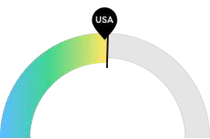
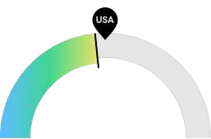
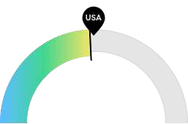

174

142
59

Retiring Soon

Racial Diversity

Gender Diversity

Retirement risk is about average in your area. The national average for an area this size is 169* employees 55 or older, while there are 174 here.
Racial diversity is about average in your area. The national average for an area this size is 156* racially diverse employees, while there are 142 here.
Gender diversity is about average in your area. The national average for an area this size is 62* female employees, while there are 59 here.

*National average values are derived by taking the national value for Medical Equipment Repairers and scaling it down to account for the difference in overall workforce size between the nation and your area. In other words, the values represent the national average adjusted for region size.

Occupation Age Breakdown
 | % of Jobs | Jobs
⬤ 14-18 | 0.1% | 1
⬤ 19-24 | 3.4% | 19
⬤ 25-34 | 18.7% | 104
⬤ 35-44 | 19.7% | 110
⬤ 45-54 | 27.0% | 151
⬤ 55-64 | 25.0% | 139
⬤ 65+ | 6.2% | 34

Occupation Race/Ethnicity Breakdown

% of Jobs Jobs

⬤ White 74.5% 416
⬤ Black or African American 12.5% 70
⬤ Hispanic or Latino 6.0% 33
⬤ Asian 5.8% 32
⬤ Two or More Races 1.1% 6
⬤ American Indian or Alaska Native 0.1% 0
⬤ Native Hawaiian or Other Pacific Islander 0.0% 0

Occupation Gender Breakdown
% of Jobs Jobs
⬤ Males 89.4% 499
⬤ Females 10.6% 59

National Educational Attainment

% of Jobs

⬤ Less than high school diploma 5.1%

⬤ High school diploma or equivalent 20.3%

⬤ Some college, no degree 29.3%

⬤ Associate's degree 22.0%

⬤ Bachelor's degree 19.4%

⬤ Master's degree 3.4%

⬤ Doctoral or professional degree 0.4%

Occupational Programs

1 Program

Of the programs that can train for this job, 1 has produced completions in the last 5 years.

23 Completions (2018)

The completions from all regional institutions for all degree types.

61 Openings (2018)

The average number of openings for an occupation in the region is 271.

CIP Code Top Programs Completions (2018)

15.0401 Biomedical Technology/Technician 23

Top Schools | Completions (2018)
Community College of Philadelphia | 20
Pennsylvania Institute of Technology | 2
DeVry University-Pennsylvania | 1

Appendix A - Data Sources and Calculations

Location Quotient
Location quotient (LQ) is a way of quantifying how concentrated a particular industry, cluster, occupation, or demographic group is in a region as compared to the nation. It can reveal what makes a particular region unique in comparison to the national average.

Occupation Data
Emsi occupation employment data are based on final Emsi industry data and final Emsi staffing patterns. Wage estimates are based on Occupational Employment Statistics (QCEW and Non-QCEW Employees classes of worker) and the American Community Survey (Self-Employed and Extended Proprietors). Occupational wage estimates also affected by county-level Emsi earnings by industry.

Staffing Patterns Data
The staffing pattern data in this report are compiled from several sources using a specialized process. For QCEW and Non-QCEW Employees classes of worker, sources include Occupational Employment Statistics, the National Industry-Occupation Employment Matrix, and the American Community Survey. For the Self-Employed and Extended Proprietors classes of worker, the primary source is the American Community Survey, with a small amount of information from Occupational Employment Statistics.

Cost of Living Data
Emsi cost of living data is based on the Cost of Living Index published quarterly by the Council for Community and Economic Research (C2ER).

Emsi Job Postings
Job postings are collected from various sources and processed/enriched to provide information such as standardized company name, occupation, skills, and geography.

Institution Data
The institution data in this report is taken directly from the national IPEDS database published by the U.S. Department of Education's National Center for Education Statistics.

Occupation Overview

Medical Equipment Repairers
in Philadelphia County, PA

Emsi Q1 2020 Data Set | www.economicmodeling.com

Medical Equipment Repairers (SOC 49-9062):
Test, adjust, or repair biomedical or electromedical equipment.

Sample of Reported Job Titles: Biomedical Equipment Technician (BMET) Service Technician
Repair Technician
Certified Biomedical Equipment Technician (CBET) Biomedical Equipment Support Specialist Biomedical Equipment Specialist
Biomedical Engineering Technician (BMET) Biomedical Electronics Technician
Biomed Tech (Biomedical Technician) X-ray Service Technician

Related O*NET Occupation:
Medical Equipment Repairers (49-9062.00)

Contents

What is Emsi Data? 1
. .
. . . . . . . . . . . . . . . . .
Report Parameters 2
. .
. . . . . . . . . . . . . . . .
Executive Summary 3
. .
. . . . . . . . . . . . . . . . .
Jobs 4
. .
. . . .
Compensation 6
. .
. . . . . . . . . . . . .
Job Posting Activity 7
. .
. . . . . . . . . . . . . . . . .
Demographics 9
. .
. . . . . . . . . . . . .
Occupational Programs 13
. . .
. . . . . . . . . . . . . . . . . . . .

What is Emsi Data?

Emsi data is a hybrid dataset derived from official government sources such as the US Census Bureau, Bureau of Economic Analysis, and Bureau of Labor Statistics. Leveraging the unique strengths of each source, our data modeling team creates an authoritative dataset that captures more than 99% of all workers in the United States. This core offering is then enriched with data from online social profiles, resumés, and job postings to give you a complete view of the workforce.
Emsi data is frequently cited in major publications such as The Atlantic, Forbes, Harvard Business Review, The New York Times, The Wall Street Journal, and USA Today.

Report Parameters

1 Occupation

49-9062 Medical Equipment Repairers

1 County

42101 Philadelphia County, PA

Class of Worker
QCEW Employees

The information in this report pertains to the chosen occupation and geographical area.

Executive Summary

Aggressive Job Posting Demand Over a Thin Supply of Regional Jobs
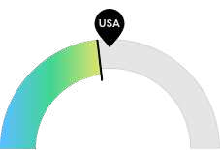
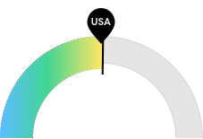
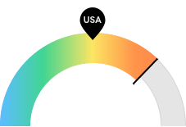

175

$49,406
13

Jobs (2014)

Compensation

Job Posting Demand

Philadelphia County, PA is not a hotspot for this kind of job. The national average for an area this size is 195* employees, while there are 175 here.
Earnings are about average in Philadelphia County, PA. The national median salary for Medical Equipment Repairers is $49,213, compared to
$49,406 here.
Job posting activity is high in Philadelphia County, PA. The national average for an area this size is 7* job postings/mo, while there are 13 here.

*National average values are derived by taking the national value for Medical Equipment Repairers and scaling it down to account for the difference in overall workforce size between the nation and Philadelphia County, PA. In other words, the values represent the national average adjusted for region size.

Jobs

Regional Employment Is Lower Than the National Average

An average area of this size typically has 195* jobs, while there are 175 here. This lower than average supply of jobs may make it more difficult for workers in this field to find employment in your area.
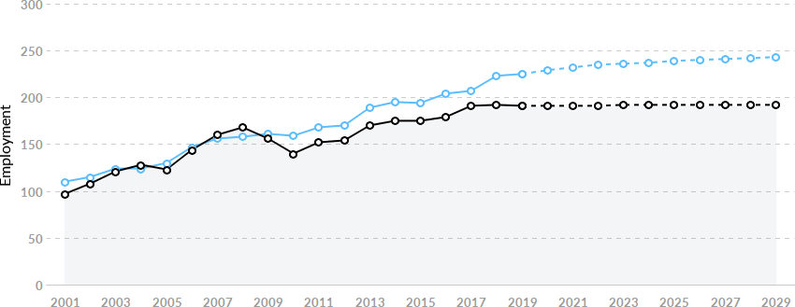

Region | 2014 Jobs | 2020 Jobs | Change | % Change
- Philadelphia County, PA | 175 | 191 | 16 | 8.9%
- National Average | 195 | 229 | 34 | 17.4%

*National average values are derived by taking the national value for Medical Equipment Repairers and scaling it down to account for the difference in overall workforce size between the nation and Philadelphia County, PA. In other words, the values represent the national average adjusted for region size.

Regional Breakdown

County 2014 Jobs
Philadelphia County, PA 175

Most Jobs are Found in the General Medical and Surgical Hospitals Industry Sector

Industry
% of Occupation in Industry (2014)

⬤ General Medical and Surgical Hospitals 31.7%

⬤ Professional and Commercial Equipment and 18.6% Supplies Merchant Wholesalers

⬤ Electronic and Precision Equipment Repair and 8.3% Maintenance

⬤ Health and Personal Care Stores 6.9%

⬤ Specialty (except Psychiatric and Substance 6.6% Abuse) Hospitals

⬤ Outpatient Care Centers 6.4%

⬤ Other 21.5%

Compensation

Regional Compensation Is the Same Cost as the Nation

For Medical Equipment Repairers, the 2018 median wage in Philadelphia County, PA is $49,406, while the national median wage is $49,213.
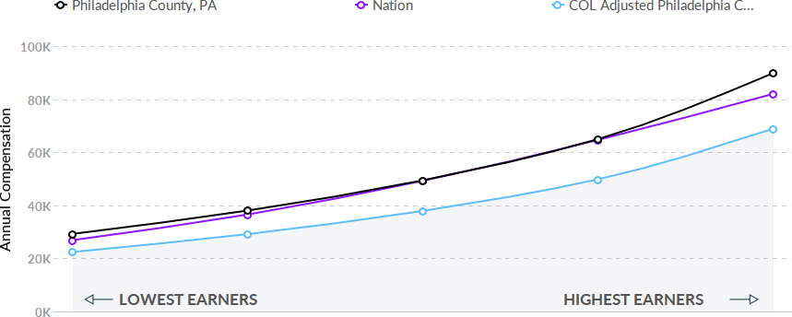

Job Posting Activity

551 Unique Job Postings

The number of unique postings for this job from Sep 2016 to Mar 2020.

155 Employers Competing

All employers in the region who posted for this job from Sep 2016 to Mar 2020.

47 Day Median Duration

Posting duration is 13 days longer than what's typical in the region.

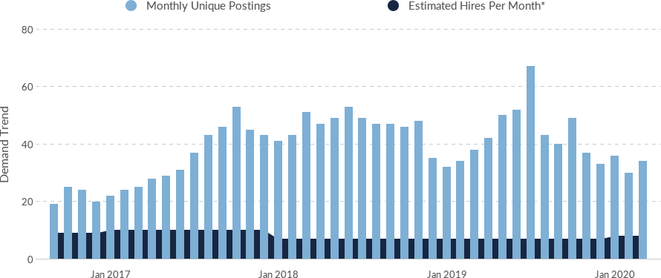

Occupation
Avg Monthly Postings (Sep 2016 -
Mar 2020)
Avg Monthly Hires (Sep 2016 - Mar
2020)

Medical Equipment Repairers

39 8

*A hire is reported by the Quarterly Workforce Indicators when an individual's Social Security Number appears on a company's payroll and was not there the quarter before. Emsi hires are calculated using a combination of Emsi jobs data, information on separation rates from the Bureau of Labor Statistics (BLS), and industry-based hires data from the Census Bureau.

Top Companies | Unique Postings |  | Top Job Titles | Unique Postings
General Electric Company | 31 |  | Biomedical Equipment Tech… | 231
Penn Medicine | 28 |  | Equipment Technicians (Ins… | 44
The Children's Hospital of Ph… | 25 |  | Maintenance Technicians (In… | 34
COMPASS GROUP PLC | 24 |  | Equipment Service Technici… | 20
Aramark Corporation | 22 |  | Field Service Engineers | 18
Davita Inc. | 20 |  | Imaging Engineers (Architec… | 18
Universal Hospital Services,… | 18 |  | Medical Sales Representativ… | 18
BSI Group America Inc. | 16 |  | Equipment Specialists | 16
SODEXO | 14 |  | Field Service Technicians | 14
Fresenius Medical Care | 13 |  | Assembly Mechanics | 12

Demographics

Retirement Risk Is About Average, While Overall Diversity Is High
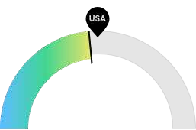
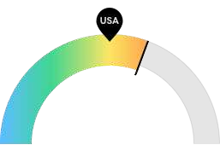
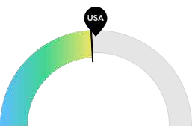
53
73
20

Retiring Soon

Racial Diversity

Gender Diversity

Retirement risk is about average in Philadelphia County, PA. The national average for an area this size is 58* employees 55 or older, while there are 53 here.
Racial diversity is high in Philadelphia County, PA. The national average for an area this size is 53* racially diverse employees, while there are 73 here.
Gender diversity is about average in Philadelphia County, PA. The national average for an area this size is 21* female employees, while there are 20 here.

*National average values are derived by taking the national value for Medical Equipment Repairers and scaling it down to account for the difference in overall workforce size between the nation and Philadelphia County, PA. In other words, the values represent the national average adjusted for region size.

Occupation Age Breakdown
 | % of Jobs | Jobs
⬤ 14-18 | 0.1% | 0
⬤ 19-24 | 3.3% | 6
⬤ 25-34 | 21.5% | 41
⬤ 35-44 | 21.9% | 42
⬤ 45-54 | 25.4% | 48
⬤ 55-64 | 22.3% | 42
⬤ 65+ | 5.5% | 11

Occupation Race/Ethnicity Breakdown

% of Jobs Jobs

⬤ White 61.7% 118
⬤ Black or African American 20.0% 38
⬤ Hispanic or Latino 8.9% 17
⬤ Asian 7.7% 15
⬤ Two or More Races 1.5% 3
⬤ American Indian or Alaska Native 0.1% 0
⬤ Native Hawaiian or Other Pacific Islander 0.0% 0

Occupation Gender Breakdown
% of Jobs Jobs
⬤ Males 89.4% 171
⬤ Females 10.6% 20

National Educational Attainment

% of Jobs

⬤ Less than high school diploma 5.1%

⬤ High school diploma or equivalent 20.3%

⬤ Some college, no degree 29.3%

⬤ Associate's degree 22.0%

⬤ Bachelor's degree 19.4%

⬤ Master's degree 3.4%

⬤ Doctoral or professional degree 0.4%

Occupational Programs

1 Program

Of the programs that can train for this job, 1 has produced completions in the last 5 years.

20 Completions (2018)

The completions from all regional institutions for all degree types.

20 Openings (2018)

The average number of openings for an occupation in the region is 111.

CIP Code Top Programs Completions (2018)

15.0401 Biomedical Technology/Technician 20

Top Schools Completions (2018)

Community College of Philadelphia 20

Data Sources and Calculations

Location Quotient
Location quotient (LQ) is a way of quantifying how concentrated a particular industry, cluster, occupation, or demographic group is in a region as compared to the nation. It can reveal what makes a particular region unique in comparison to the national average.

Occupation Data
Emsi occupation employment data are based on final Emsi industry data and final Emsi staffing patterns. Wage estimates are based on Occupational Employment Statistics (QCEW and Non-QCEW Employees classes of worker) and the American Community Survey (Self-Employed and Extended Proprietors). Occupational wage estimates also affected by county-level Emsi earnings by industry.

Staffing Patterns Data
The staffing pattern data in this report are compiled from several sources using a specialized process. For QCEW and Non-QCEW Employees classes of worker, sources include Occupational Employment Statistics, the National Industry-Occupation Employment Matrix, and the American Community Survey. For the Self-Employed and Extended Proprietors classes of worker, the primary source is the American Community Survey, with a small amount of information from Occupational Employment Statistics.

Cost of Living Data
Emsi cost of living data is based on the Cost of Living Index published quarterly by the Council for Community and Economic Research (C2ER).

Emsi Job Postings
Job postings are collected from various sources and processed/enriched to provide information such as standardized company name, occupation, skills, and geography.

Institution Data
The institution data in this report is taken directly from the national IPEDS database published by the U.S. Department of Education's National Center for Education Statistics.

